Matthew Ford

1. Made all of my inputs in my “new” model the same as the last “transient” assignment model. Only thing I changed was dz is now 100 instead of 10. My well is also at the center of the domain 25,25. My new model is 3 layers with a confining middle layer with a low K. I had to change the constant head at the RHS to 40 instead of 30 otherwise MODFLOW wouldn’t run. Ended up having to change the horizontal K to 1 m/d instead of 0.1 to not dewater the domain past the confined layer. I have no recharge over the domain.
2. My thought how to integrate the transient model into my steady state model was to pump the transient model at the given rate of 500 m^3/day for the given times periods of 25,50,75,100 years and see the head response. I can then adjust the pumping rate to match that head response as we did in assignment 7. I will then take those pumping rates into my new model and use them to simulate capture for the given years. The models are slightly different but this should give us a rough estimate.
3. Here are the figures with head at the well to figure out an avg once reaching steady state. (25 years is before reaching steady state be we will do our best). As determined in assignment 7 this model reaches steady state after 43 years so the heads to match for >50yrs should be around 37.75 m. It looks like the head to match for the 25 year scenario is around 38.25 m.   
     
     
     
     
     
     
     
     
     
     
     
     
     
     
     
     
     
     
     
     
     
     
     
     
     
     
   A pumping rate of 260 m^3/day matches the head for >50 yrs according to our analysis. 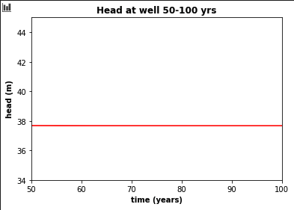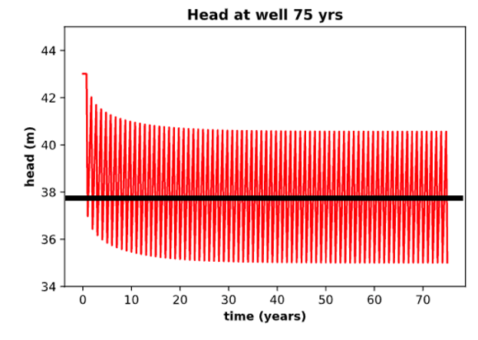

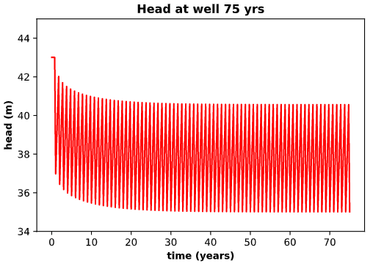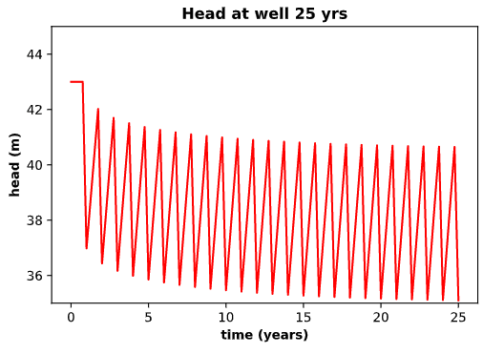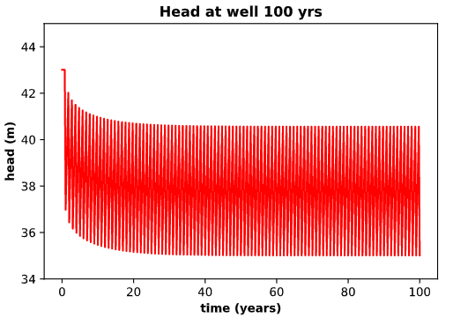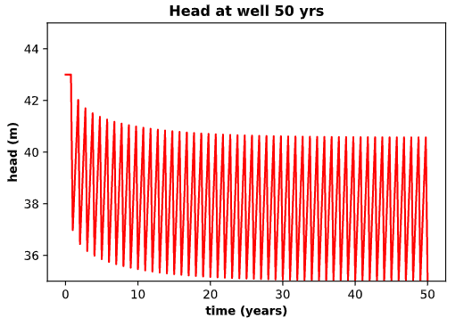

A pumping rate of 240 m^3/day seems to match the head for 25 yrs.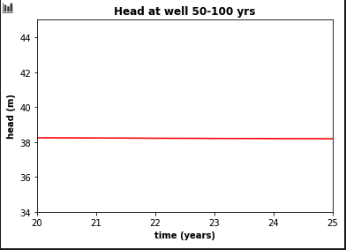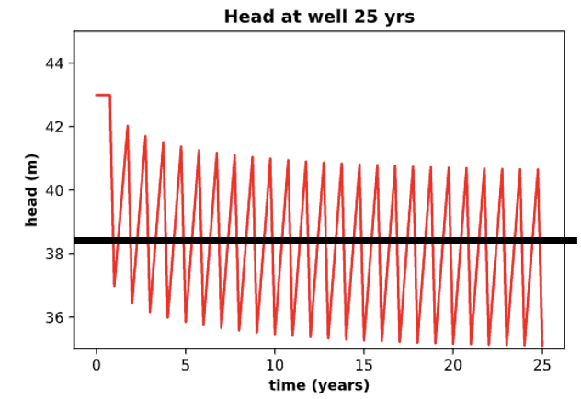

1. Now I will take those pumping rates of 240 m^3/day and 260 m^3/day and apply them to my model to see how capture changes.   
     
   **240 m^3/day**  
   As we can see at a pumping rate of 240 m^3/day no water from the boundary is captured from the surface layer but there is capture from the boundary in the confined layer.

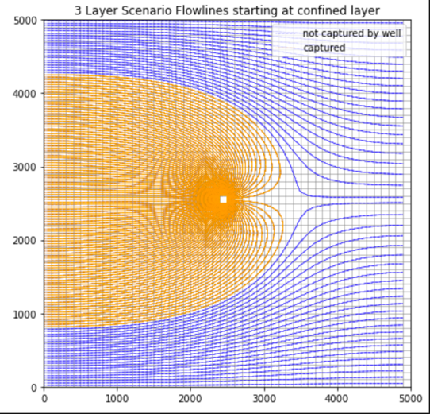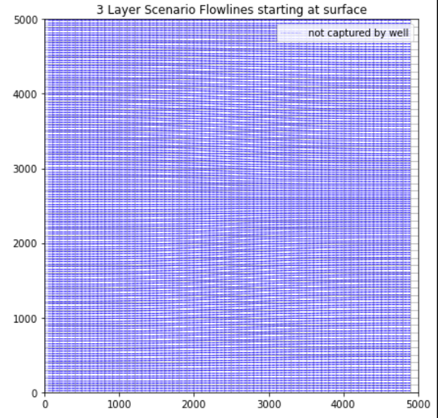

**260 m^3/day**

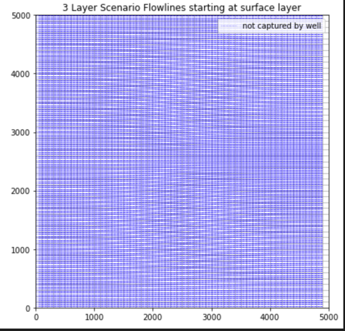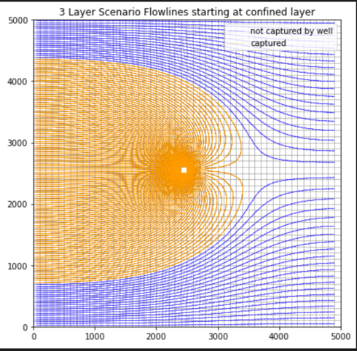

As we can see increasing the pumping rate by 20 m^3/day does NOT make any boundary particles reach the well when starting at the surface. We can see that the capture zone is slightly larger in the graph with the particles starting in the confined layer.   
  
Due to the properties of the confining layer and the small pumping rate no particles from the boundary surface reach the well. This is important if some sort of contaminant is dropped into the subsurface in the upper most layer at the boundary. This would be a safe pumping rate for the confined aquifer to never see that contaminant in the well. Well is SAFE to drink from!

After messing around with the pumping rate, a rate of 450 m^3/day would cause particles from the surface layer at the boundary to reach the well. 